**General introduction**

Don't you ever laugh as a hearse goes by,

For you may be the next to die.

They wrap you up in a big white sheet,

And cover you up from your head down to your feet.

They put you in a big black box,

And cover you up with dirt and rocks.

All goes well for about a week,

And then your coffin begins to leak.

The worms crawl in, the worms crawl out,

The worms play pinochle on your snout.

They eat your eyes, they eat your nose,

They eat the jelly between your toes.

A big green worm with rolling eyes,

Crawls in your stomach and out your eyes.

Your stomach turns a slimy green,

And pus pours out like whipping cream.

You spread it out on a slice of bread,

And that's what you eat when you are dead.

**To watch animals feed you will need to place food in containers. There is a danger of fouling the containers. Please be careful and add only the amounts specified in the instructions to your containers. If a container looks foul to you, call the lab instructors attention to it so she can add new water. If he instructs you to do so, make sure you know whether you are to add spring or salt water to your bowl.**

A rule of thumb is that Clitellates (earthworms and relatives), are terrestrial or fresh water forms, Polychaetes are salt-water forms.

**Background:**

Annelida consists of the segmented worms in the major classes Polychaeta (marine worms), and Clitellata (earthworms and relatives), with a total of about 12,000 known species in marine, freshwater, and terrestrial environments.

Most annelids have chitinous bristles, or chaetae, secreted by epidermal cells, that project from the body. The body wall consists of a **collagenous cuticle** secreted by the monolayered epidermis. The **coelom is large, segmentally compartmented,** lined and well developed in polychaetes and oligochaetes but reduced in leeches.

The circulatory system of most annelids is a set of tubular vessels, some of which are contractile and serve as hearts. The circulatory system is absent or greatly reduced in leeches. The system includes a dorsal longitudinal vessel above the gut in which blood moves anteriorly, a ventral longitudinal vessel below the gut, in which blood moves posteriorly, and paired segmental vessels that connect the dorsal and ventral vessels. The digestive, circulatory, and nervous systems are continuous and pass through the segments.

Respiration is accomplished in a variety of ways. In some, the general body surface is sufficient but gills are present in most polychaetes, many leeches, and a few oligochaetes. Excretory organs are metanephridia or protonephridia and typically one pair is present in each segment. These osmoregulatory organs are best developed in freshwater and terrestrial species. The sexes are separate in polychaetes but oligochaetes and leeches are hermaphroditic. In the ancestral condition paired clusters of germ cells were present in each segment and released developing gametes into the coelom.

____________________________________________________________

Please check with your lab instructor on activity sequence. We often receive species that we cannot guarantee will be available next week, and so the sequence of activities may have to be changed.

**Clitellata**

**Activity one. External Anatomy and locomotion of the common night crawler**

**Obtain an earthworm, *Lumbricus terrestris*. Place it in a large dish to study its external anatomy and locomotion.**

Orientation

Examine the external features of the worm. The anterior end is usually larger than the posterior and is round in cross section whereas the posterior tends to be flattened dorsoventrally

**Clitellum**

A band of thickened secretory epithelium, the clitellum (clitell = saddle), girdles the body near the anterior end. The clitellum secretes a mucous cocoon, into which gametes and albumen are released and where fertilization occurs,

Segments

The body is segmented and each segment is separated from its neighbors by a distinct circumferential groove.

**Answer the following questions in your journal.**

**____________ How many segments contribute to the clitellum? Compare your counts with those made by other students. Does the number of segments in each region, pre clitellum, clitellum and post clitellum numbers appear to be constant or variable? Pre____________ Post _______________**

Chaetae or Setae

The eight small chaetae or setae on each segment (except the first) are usually visible with adequate magnification (25X). Chaetae or setae are small chitinous bristles emerging from pores in the integument on the ventral half of the worm. The setae are arranged in four pairs, two on each side The chaetae are used as anchors when burrowing to hold parts of the worm against the so that elongation of the animal results in controlled, usually forward, motion.

The chaetae or setae are equipped with protractor and retractor muscles and are retractile. In your specimen they may be withdrawn in some, or even all, of the segments. Careful examination, however, should reveal some segments with extended setae. Setae are amber or brown, slightly curved, and short.

A ventral view of *Lumbricus.* The worm has been rolled slightly to reveal part of the right side.

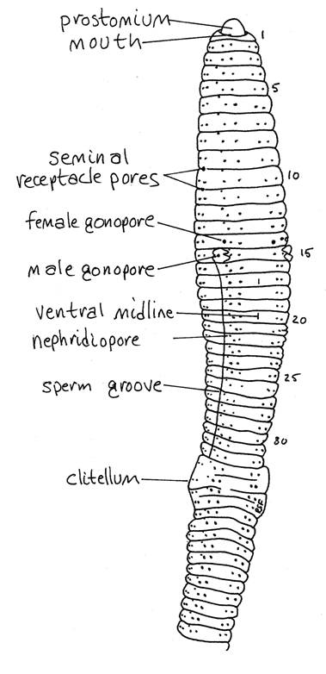

Rinse your worm gently with tap water and hold it in your hand on the stage of the dissecting microscope. Focus on the lateral body wall and watch the chaetae. You may see the animal retract or protract some of its chaetae while you watch. Place it on a clean dish, and watch it move. **Does it seem to have difficulty moving on the smooth glass surface. Place some stones and dirt in the dish and now watch it move. a. Explain why it was difficult for the earthworm with a muscle that essentially act to distort a hydroskeleton to move on the glass dish but not the dish that contains dirt and stones**. **b. When the earthworm moves in dirt (or wet sand) do any segments move as a unit? c. Does the wave of contraction and relaxation move from front to back or back to** front?

***Activity two. Feeding and circulation in Lumbriculus variegates*.** *L. variegates*is a detritus feeder like the earthworm and a perfect example of severe miniaturization of form.

**As always make sure you record your observations in your journal.**

**a. You may be able at the highest power of your stereoscope to focus and watch them feed. Use the fish food provided. Add a few tiny crushed pieces of one flake, or one flake to the bowl. As always record your observation. Notice how transparent at high power these worms are.**

These worms are often used for experiments that look at the effects of drugs on cardiovascular function.

**b. Place your worm in a plastic pipette and let it move to the tip. Then place the tip of a capillary tube close to the tip of the pipette and gently squeeze. The worm should move into the capillary tube, which you can place then in a small observation dish. Observe the internal anatomy of the worm. Can you trace blood flow from dorsal to ventral? Time dorsal vessel contraction rate.**

**Take a video or photographs of blood flow, showing the changes in vessel diameter. Document closed circulation with these specimens. In other words, show side vessels connecting to dorsal and ventral veins and arteries.**

**Then add a bit of alcohol (70 % ETHANOL ONLY-Alcohol is very toxic to invertebrates so start with 1ml or less in a dish 6 inches in diameter. ) to the bowl or simply place your bowl on an ice block. Different pairs at a table may want to try different treatments and then exchange results. What is the effect on heart rate? Describe the effect, noting whether you used ice or alcohol in your notebook. Discard any specimens used and rinse bowl under running water for a minute or two, especially if you used alcohol. Try to save capillary tubes.**

**______________________________________________________**

**Sedentary Polychaetes**

Sedentary polychaetes are usually adapted to living permanently in tubes or burrows; some attach themselves to rocks or piers. Many sedentary polychaetes, like the lugworm, *Arenicola*, live in burrows in sand or mud. The majority, however, are tube builders. Tubes of different species vary greatly in their composition and structure. They may be composed of sand, shell, or other particles held together with mucus, or made entirely of organic substances secreted by the worm that harden on contact with water.

Sedentary polychaetes have greatly modified head regions for specialized feeding habits. Many are adapted for feeding on organic matter deposited on the ocean floor. The parapodia are reduced in the sedentary polychaetes, and the setae of many tube-dwelling forms are hooked to help the worm hold itself to the wall of its tube.

**Activity three: Fan worms. Just observe fan worms in their habitat, we will have more specimens for you to video, next week.**

**We have several living representatives of the tube dwelling polychaetes.**

**The Sabillids are commonly known as "fanworms" or "feather duster" worms due to a colorful appearance of a maroon or red-colored tentacular branchial crown**.

We may have

***Sabellastarte* sp. (classic feather duster)**

***Potamilla neglecta* (a solitary fan worm**)

**H*ydroides dianthus* (calcareous tubeworm**)

They are indirect deposit-feeders. They have no proboscis. While feeding they spread out their branchial crowns to trap suspended particles and to sweep with their long mobile palps picking up deposited material (filter-feeding). Only suitable sized particles are ingested while others are rejected at the mouth. The more primitive members making temporary mucus tubes and creep around actively. The large ones never leave their tubes and are associated with shallow water but smaller ones are able to move around and are common in deep seas.

**Obtain a feather duster worm and place in a dish of sea water (Salt water only please). Allow it to acclimatize to its new environment. Study its feeding device under the stereoscope. Include a movie or several photographs of its filter feeding in your notebook. Use live phytoplankton available for feeding.**

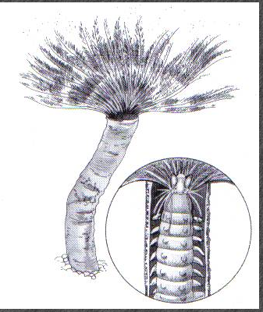

**Worm in tube**

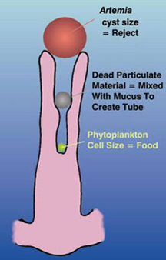

The particles that land on the grooves can be sorted with respect to size.

**Activity four: Other sedentary worms. There are other sedentary worms available for you to observe. Obtain photographs and compare the morphology of at least one other specimen to the feather duster worms. Pay particular attention to the head, which will tell you how these animals feed. For example, some sedentary worms have long tentacles with groves on them. These act as the “feathers” of a feather duster worm. The food particles are moved along by cilia in these grooves toward the mouth.**

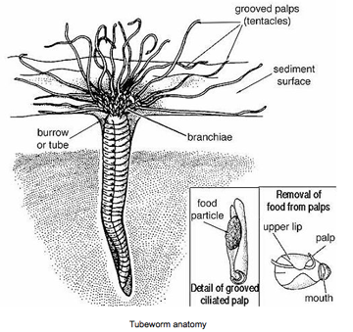**Specimens available in the laboratory include the following.**

**Terebellids or cirratulids** (spaghetti (many feeding tentacles) or hair worms (one pair of feeding tentacles).

Terebellids are very complex animals, and have a body that may be divided into three regions, a head, thorax, and abdomen. The head is specialized for feeding and respiration, the thorax for moving in the tube, and the abdomen for the digestion of food.

***Amphitrite ornata*, a terebellid named after a Greek goddess.**

***Cirratulus cirratus, a spaghetti worm***

**S*pirorbis spirorbis* (Sinistral spiral tubeworm)** In this genus and in the family Spirorbidae all species live in permanent calcareous tubes cemented to algae, shells, or rocks

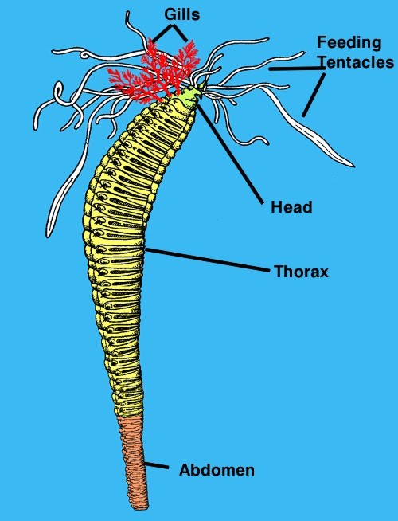

***Cirratulus cirratus***

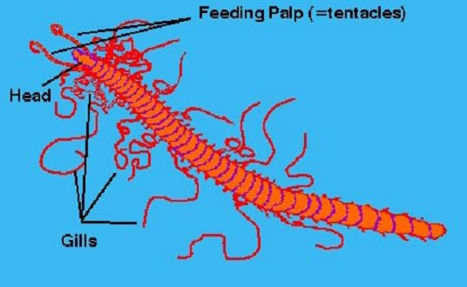

***Spirorbis***

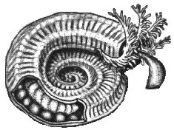

**Activity six: Errant Polychaetes**

Errant polychaetes include actively crawling or swimming forms, which may, however, also spend time in burrows or crevices, or under rocks on the seashore.. Many are predators on small invertebrates; some are scavengers.. Most errant polychaetes have well-developed head regions, which bear eyes, sensory tentacles, and a specialized organ, the nuchal organ, thought to detect chemicals. The anterior end of the gut often forms a protrusible structure, the proboscis, sometimes equipped with strong chitinous jaws and used in feeding. The setae of some polychaetes, e.g., the tropical fireworm, are composed of calcium carbonate rather than chitin and are hollow. These brittle setae are easily broken off and contain a toxin that produces a painful reaction in humans. In the scaleworms, a series of overlapping scales form a covering over the animal's upper surface. In the sea mouse these scales are completely covered by long, slender, feltlike setae projecting from the parapodia.

We only have one representative of an errant polychaete and that is the bristleworm. Many errant polychaetes are ferocious predators and most aquarists remove them as soon as they are spotted. We do the same, but have saved for your observation some of our disposed specimens.

Please wear gloves when handling these specimens. They are called fire worms for a reason.

**Please observe the jaws in these specimens. Take a picture of those jaws and then obtain a video of blood flow in your specimens if you did not get a video of such in *Lubriculus*.**

